Working with the ABnC program

Introduction
The ABnC program is designed to simulate sorption dynamics within the Adams-Bogart kinetic sorption model and determine the optimal sorption parameters that best describe the experimental output curve (in terms of the least-squares method). It is assumed that the sorbent contains either one or two types of sorption sites, differing in sorption rate constants () and maximum capacities (). The number of types is specified by the user when using the program.
During the simulation, the column (length ) is conditionally divided into adjacent layers. By default, the number of layers is =50 (this can be changed in the program settings file). The greater the number of layers, the more accurately the sorption dynamics are described, but the longer the simulation. The simulation itself consists of two cyclically repeating steps: 1) the step of the convective transfer of the solution along the column (i.e., the movement of the solution from layer to layer; entering the column); 2) sorption from the solution in each layer over time (the time step of the convective transfer; it is determined by the column length, its cross-sectional area, the column flow rate, the number of cross-sections, and the column porosity). The output curve is formed as a set of concentrations in the layer solution at successive points over time.
There are two methods for calculating output concentrations (i.e., individual points on the model output curve), depending on the method of their experimental determination: instantaneous concentrations () and "integrated" concentrations (). Instantaneous concentrations coincide with the concentrations in the last layer of the column at each point in time. In real-world studies, determining such concentrations is not always possible. Typically, continuous aliquots of a certain volume are collected at the column outlet, in which case the solution concentration in each aliquot is the "integrated" output concentration. Instantaneous and "integrated" concentrations are related by the equation:
,
where are the times of sampling of the corresponding aliquots.

The program provides a choice of the method for calculating output concentrations (if the option “"integral" concentrations” is checked, “integral” concentrations are calculated, otherwise – instantaneous).

Data preparation
Before calculating the model parameters, an input data file must be created. The file must have the "ABnC" extension. The file is a text one and can be created and edited in the standard Notepad application. The name can be arbitrary, but without spaces. Additionally, the program settings file, AB.ini, must be located in the same folder as the data file. The meanings of some useful settings file parameters are explained below. Example of a data file:
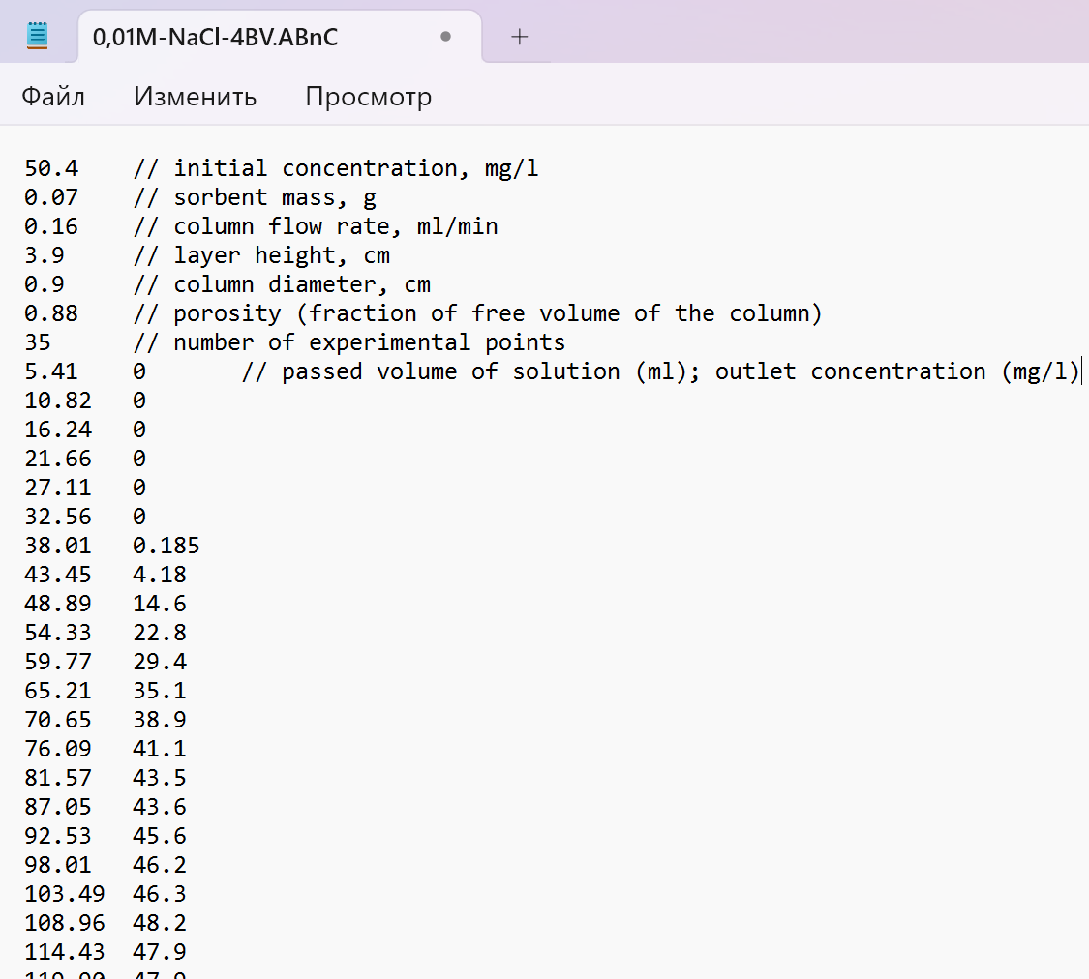
Fig. 1 Example of a data file

The order of the source data must be exactly as shown in Fig. 1.
Important: All numbers must be separated by a "." (period, not a comma!). Using a comma when reading data will result in a data type conversion error.
Comments in the data file (text after the "//") are optional, but if they are present, there must be at least one space or tab between the parameter value and the "//" characters.
Most of the parameters in the input data file are predetermined values (sorbent mass, column flow rate, sorbent bed height, column diameter, column inlet concentration, number of experimental points on the output curve, and the values at these points). The column porosity (i.e., the fraction of the column volume not occupied by the sorbent) is not always precisely known. Numerical experiments have shown that, for porosity greater than 0.7, the calculation results depend weakly on the exact porosity value. Otherwise, this parameter must be determined in advance using some experimental method.
Below is the structure of the data file by rows.
Line number | Parameter
1 | Initial concentration, mg/l *
2 | Sorbent mass, g
3 | Column flow rate, ml/min
4 | Layer height, cm
5 | Column diameter, cm
6 | Column porosity (fraction of free column volume)
7 | Number of experimental points ()
8 … | From this line onwards – pairs of experimental point values, separated by a space or tab: omitted volume (ml); concentration at the column outlet (mg/l)
*The units of measurement of the parameters may differ from those given in the table, provided, of course, that they are consistent with each other.
The values in the AB.ini program settings file (text format) can generally be left unchanged, but some parameters whose modification may occasionally be useful are explained below. (One should mention that all parameters whose values can be adjusted by the user are located in the [Defaults] section. Values in the remaining sections define the program's internal settings and should not be changed.) Example of an AB.ini file:
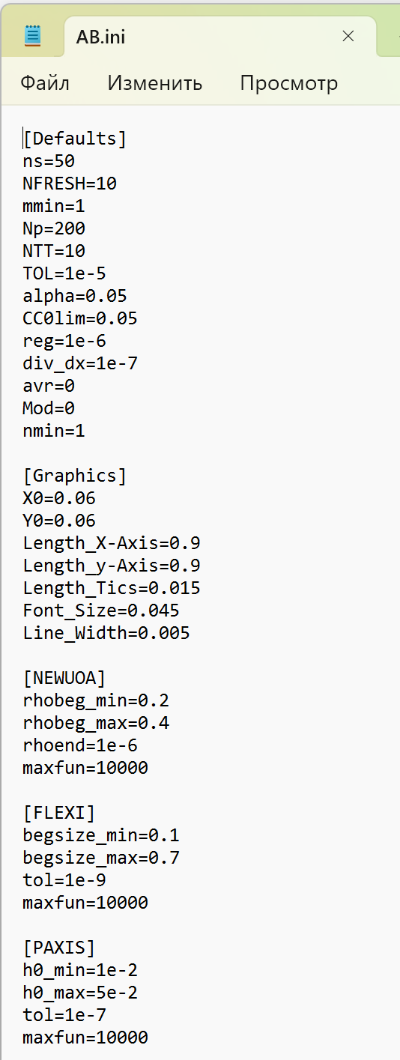
Fig. 2 Example AB.ini file
Section [Defaults]:
ns – the number of sections along the length of the column (50*);
Np – the number of interpolation points in the model output curve (200);
NTT – the number of terms in the expansion of functions in a Taylor series (10) (as it increases, the accuracy of integration increases, but the calculation time increases too);
TOL – the relative accuracy of integration of kinetic equations (1e-5);
alpha – the confidence level (for calculating confidence intervals) (0.05);
CC0lim – the parameter that determines the linearization region (see below) of the experimental points (0.05). During linearization, only those experimental points that satisfy the condition are taken into account:
,
where is the experimental value of the output concentration at point ; is the initial concentration.
*Default values are given in brackets.

Working with the program
After generating the data file and editing (if necessary) the AB.ini file, run ABnC.exe (it can be located anywhere on the disk). Load the data file (click the "Open" button):
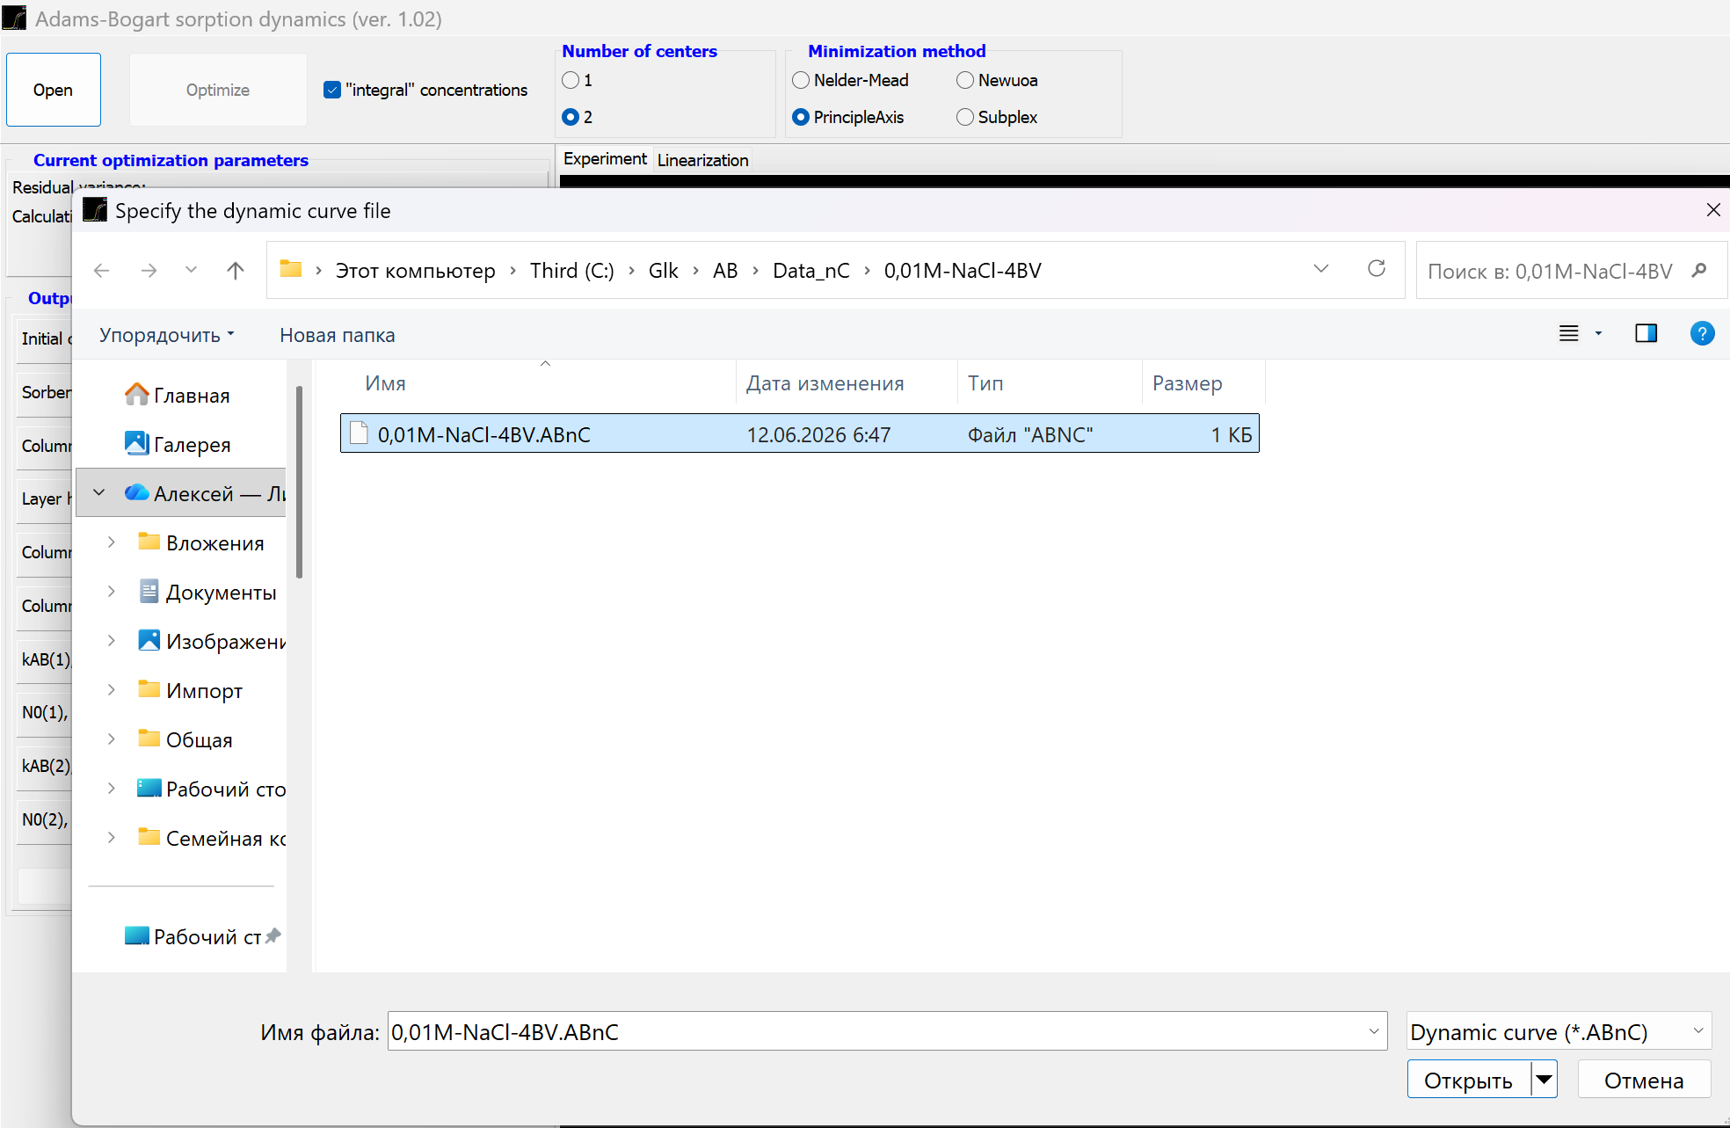

After loading the data file, it is automatically processed to determine the initial values of the sorption rate constants and site capacities. These are determined using the linearized Adams-Bogart dynamics equation. (The linearization range is determined by the current value of the CC0lim parameter):
experimental values at point of the output curve; column flow rate; initial concentration of the solution. Parameters and are determined by processing the experimental output curve according to the above equation using any linear least squares program (it is worthwhile to first display the transformed points on the graph and select the linear section for least squares processing). After determining and , the parameters of the single-center approximation are calculated as follows:
layer height in a column.
Linearization results can be checked in the “Linearization” tab and in the <data file name>.res.linear.txt file, which is written to the same folder as the data file. The results are output in text format and can be viewed with standard text file viewers (for example, Notepad). Logically, all results are displayed in separate columns. Columns are separated from each other by tabs (so that the results can be easily exported to spreadsheet programs (Excel, SigmaPlot, Origin, etc.) for further processing (plotting graphs, etc.). The first line of the file contains conventional column headings, separated by tabs. After pasting the file text, for example, into SigmaPlot (and moving the first line to the column headings), the following is obtained:
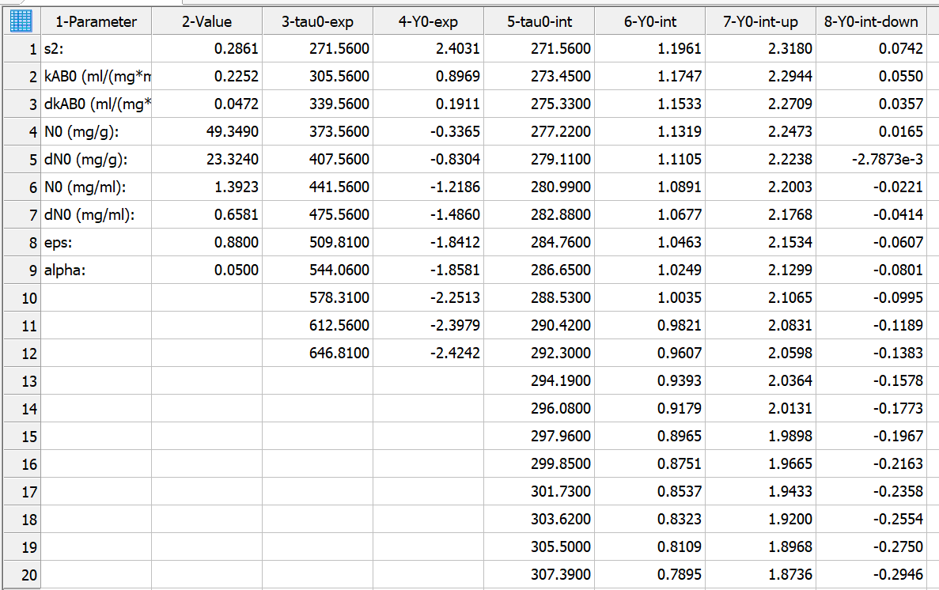
Fig. 3. Example of a linearization results file

Below in the table are descriptions of the contents of each column (lines separated by dots, excluding the first line):
Table 1. Contents of columns in the linearization results file
Column number | Description
1. | Parameter designations
2.1 | s2 (residual dispersion)
2.2 | kAB (Adams-Bogart constant)
2.3 | dkAB (confidence interval of the Adams–Bogart constant)
2.4 | N0 (sorbent capacity, mg/g)
2.5 | dN0 (confidence interval of sorbent capacity, mg/g)
2.6 | N0 (sorbent capacity, mg/ml)
2.7 | dN0 (confidence interval of sorbent capacity, mg/ml)
2.8 | eps (column porosity – fraction of free volume)
2.9 | alpha (significance level)
3. | tau0-exp (experimental times)
4. | Y0-exp (values of the function Y0)
5. | tau0-int (interpolated times)
6. | Y0-int (interpolated values of Y0)
7. | Y0-int-up (upper limit of the confidence interval of the interpolated values Y0)
8. | Y0-int-down (lower limit of the confidence interval of the interpolated values of Y0)

Next, select the minimization method (PrincipleAxis by default), the number of sorption site types, the output concentration calculation method, and click the "Optimization" button.
Data processing begins. The optimization progress is displayed in real time. Once optimization is complete, a corresponding message appears:
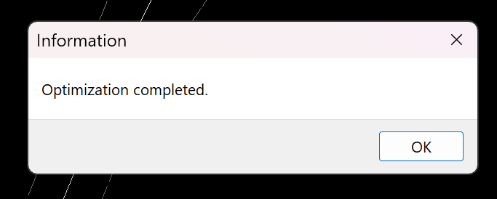

Calculation results
Depending on the type of model (one- or two-center) and the method of calculating the output concentrations (instantaneous or “integrated”), the calculation results are saved in a file named:
<ABnC file name>.res-<model type>-<concentration type>.txt
where:
<model type> - “1C” (one site); “2C” (two sites);
<concentration type> - “cumulate” (integral); “instant” (instant).
In general, the format of the optimization results file is the same as the linearization results file. Below is an example of an optimization results file for a two-center model calculation:
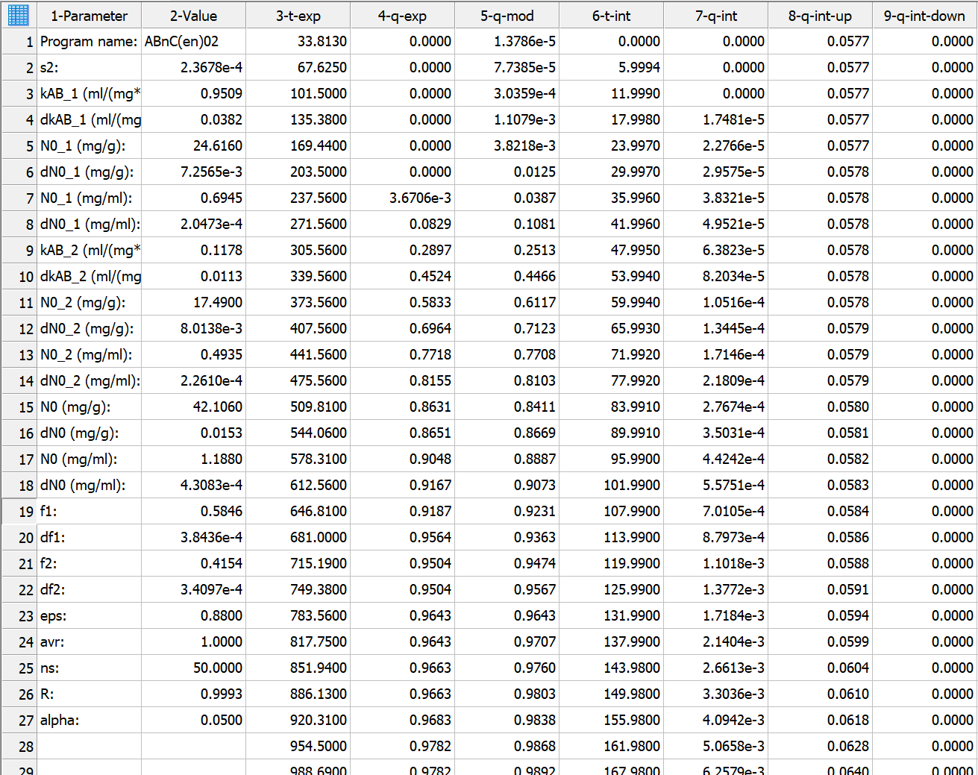

The table below describes the contents of each column (and row, separated by periods):
Table 2. Column contents in the optimization results file
Column number | Description
1. | Parameter designations
2.1 | Name of the program
2.2 | s2 (residual dispersion)
2.3 | kAB_1 (ml/(mg*min) (Adams–Bogart constant for sites 1)
2.4 | dkAB_1 (ml/(mg*min) (confidence interval of the Adams-Bogart constant for sites 1)
2.5 | N0_1 (mg/g) (sorbent capacity by sites 1)
2.6 | N0_1 (mg/ml) (sorbent capacity by sites 1)
2.7 | dN0_1 (mg/g) (confidence interval of sorbent capacity at sites 1)
2.8 | dN0_1 (mg/ml) (confidence interval of sorbent capacity by sites 1)
2.9* | kAB_2 (ml/(mg*min) (Adams–Bogart constant for sites 2)
2.10* | dkAB_2 (ml/(mg*min) (confidence interval of the Adams-Bogart constant for sites 2)
2.11* | N0_2 (mg/g) (sorbent capacity by sites 2)
2.12* | dN0_2 (mg/mg) (confidence interval of sorbent capacity at sites 2)
2.13* | N0_2 (mg/ml) (sorbent capacity by sites 2)
2.14* | dN0_2 (mg/mL) (confidence interval of sorbent capacity at sites 2)
2.15* | N0 (mg/mg) (total capacity of the sorbent)
2.16* | dN0 (mg/mg) (confidence interval of the total capacity of the sorbent)
2.17 | N0 (mg/mg) (total capacity of the sorbent)
2.18* | dN0 (mg/mg) (confidence interval of the total capacity of the sorbent)
2.19* | f1 (share of capacity of sites 1)
2.20* | df1 (confidence interval of the share of capacity of sites 1)
2.21* | f2 (share of capacity of sites 2)
2.22* | df2 (confidence interval of the share of capacity of sites 2)
2.23 | eps (column porosity - fraction of free volume)
2.24 | avr (0 - instantaneous concentrations, 1 - "integral" concentrations)
2.25 | ns (number of sections along the column length)
2.26 | R (correlation index (for nonlinear systems, the Pearson pairwise correlation coefficient is not used. Either the correlation index** or the determination coefficient is used))
2.27 | alpha (significance level)
3. | t-exp (experimental times)
4. | q-exp (experimental relative () output concentrations)
5. | q-mod (model relative output concentrations (or instantaneous or "integrated", depending on the value of “avr”))
6. | t-int (interpolated times)
7. | q-int (interpolated relative output concentrations (instantaneous, regardless of the value of “avr”)
8. | q-int-up (upper limit of the confidence interval of the interpolated relative output concentrations)
9. | q-int-down (lower limit of the confidence interval of interpolated relative output concentrations)
* In the single-center model these lines are missing.
** Correlation index:
residual variance of nonlinear regression; sample variance:

Output curve modeling
The program provides output the curve modeling based on the column geometry and sorbent parameters of the current data set. After loading the data set, the fields in the "Output Curve Modeling" window are populated:
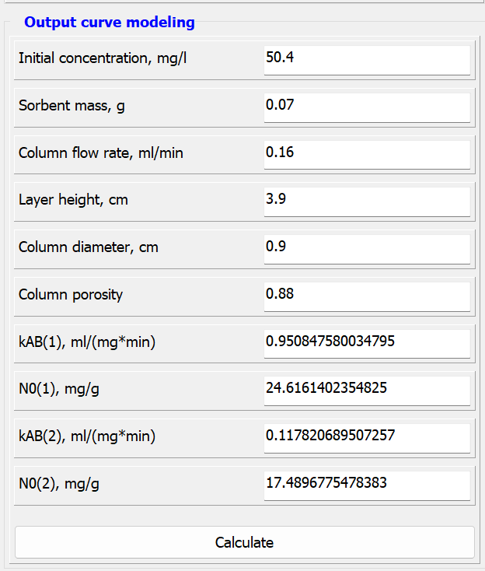
After changing these parameters and clicking the "Calculate" button, the output curve is simulated with the modified parameters (Important: any changes to the column and sorbent parameters do not change these values in the original data file). The simulation result is displayed in the program window and saved to a file with a name depending on the selected model type (the selected output concentration calculation type is ignored—instantaneous concentrations are always simulated):
<ABnC file name>.simul-<model type>.txt
Where:
<model type> - “1C” (one center); “2C” (two centers);
Below is an example of the contents of the simulation results file:
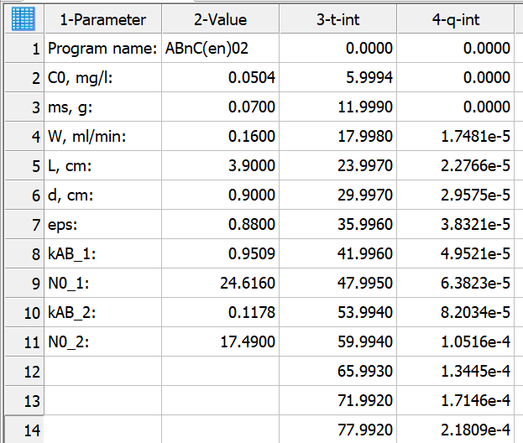
Fig. 4. Example of a simulation results file

The table below describes the content of the simulation results for the two-center model (row number separated by a period):
Table 3. Description of columns in the simulation results file
Column number | Description
1. | Parameter designations
2.1 | Name of the program
2.2 | C0, mg/l (initial concentration of solution)
2.3 | ms, g (mass of sorbent)
2.4 | W, ml/min (column flow rate)
2.5 | L, cm (layer height)
2.6 | d, cm (column diameter)
2.7 | eps (column porosity)
2.8 | kAB_1 (ml/(mg*min) (Adams–Bogart constant for sites 1)
2.9 | N0_1 (mg/g) (sorbent capacity by sites 1)
2.10* | kAB_2 (ml/(mg*min) (Adams–Bogart constant for sites 2)
2.11* | N0_2 (mg/g) (sorbent capacity by sites 2)
3. | t-int (interpolated times)
4. | q-int (interpolated relative output concentrations (instantaneous, regardless of the “avr” value)
* In the single-center model these lines are missing.
After changing the column geometry, sorbent parameters, and modeling the output curve, optimization of the modified system can be run. New values for the constants and capacities corresponding to the modified parameters will be obtained.

